**Overview**

Box Edit is an add-on feature that allows you to create or edit files directly on Box. Designed for all file types, browsers and platforms, Box Edit uses the default application installed on your computer to create or edit centralized content – Docx files open in Microsoft Word, PPTx files open in Microsoft PowerPoint, Xlsx files open in Excel, etc.

Box Edit is designed for quick edits when you’re working from the Box web app. You can open, edit and save a file without ever needing to leave the Box web app. This feature is ideal for content that’s not already synced to your computer, closing the gap between Box and your computer for even tighter collaboration.

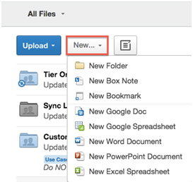

Box Edit 3 lets you create new or edit existing files straight from your Box web app. Compatible files include Word, PowerPoint, Excel, Google files, etc.

**Set-Up and Configuration**

Box Edit 3 can be downloaded from the Box website at: <https://www.box.com/box-for-devices/>

The Box Edit installer package is available for both Mac (DMG format) and Windows (MSI format).

* 1. Click the **Get Box Edit** button and download the Box Edit installer.
  2. Run the Box Edit installer and follow instructions to install or update Box Edit on your computer.

1. After the install is complete, you must restart your browser to activate the new Box Edit version. Once you restart your browser, the latest version of Box Edit is activated and will automatically receive all future updates.
2. Once you download and installed Box Edit, it will be available on any browser on your computer.

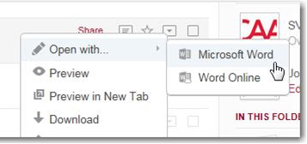

When choosing the application to open your document with, choosing the standard program will give you more options/features than choosing the online program. Note: Older files will not show an option for an online program.

**FAQs**

* **Do I have to install Box Edit on every browser I use?**

Box Edit needs to be installed only once on each computer. Once you install Box Edit, it's available on any browser on your computer.

* **Does it work on mobile browsers too?**

Box Edit does work on mobile web browsers; however, we recommend installing the Android/iPhone app for access to more features and capabilities.

* **What file types are compatible?**

All traditional Microsoft Office programs – Word, PowerPoint and Excel – as well as Adobe PDF files can be opened with Box Edit.

* **Once I save a file, does it automatically appear on Box? Is it saved as a new file within a folder or does it just replace the existing version of the file?**

After you’ve opened and revised a document using Box Edit, saving it puts the file back in Box as a new version, replacing the existing version automatically (it does not save it as a new file). As usual, you can access older versions in the version history.